Kenya Trip Travelogue
06.29.19
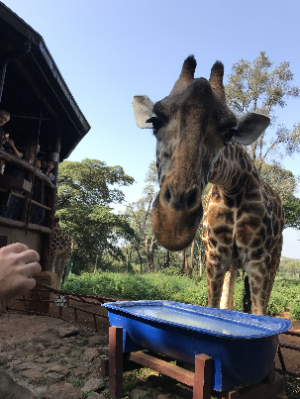
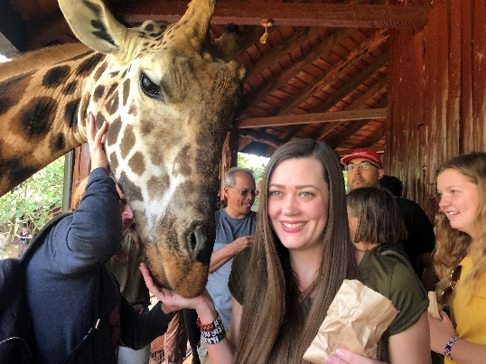
Jeff Levine and Erin Bath here. Today was a day of contrasts. We started our day at a giraffe sanctuary where we learned about some incredible work being done to preserve the giraffe population in Kenya. It was incredible to stand next to such a magnificent creature and even to think that God designed it to be so tall. Lots of kisses were had as we fed these gentle giants. It was a really fun experience for all.

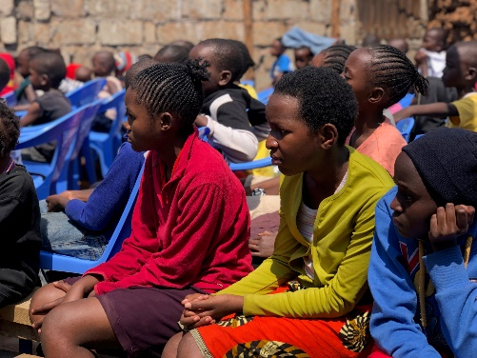
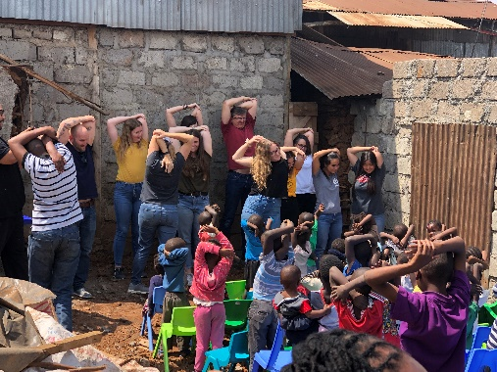
After lunch we visited Kibera. It is the third largest slum in the world. There are over 1,000,000 people who call it home. It was difficult on the eyes and on the heart. It’s hard to describe because it’s poverty on a level that most of us will never understand. When we arrived at the Hope Center we were greeted by a room filled with over 150 children waiting for us to arrive. We led them in some silly stretches and then sang several worship songs. In one of the songs, the lyrics were “we are so rich.” We couldn’t help but think our understanding of what it means to be rich is misinformed. For these children who had nothing, they joyfully sang they have everything, because they have Jesus.

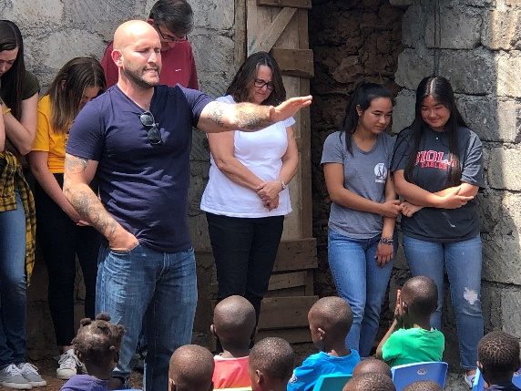
After sharing a message with the children the wanted to continue singing. It was amazing as small group after small group came up and sang special songs that the rest of the kids would join in. That they’re worship was not contingent on there circumstances challenged us and encouraged us that our worship should be something more. It should be a reflection of our relationship to God and our understanding of His infinite worth. As we left we were chased by children so happy to have spent time with us. It was bittersweet as we loved being able to invest in their lives and yet leaving and knowing they will remain there grieves the heart.

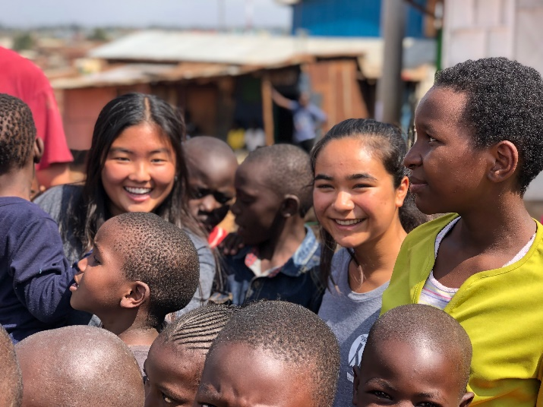
Kenya Hope is adding on to the building we met in so that more children can receive help. There is overwhelming need, but our ministry partners are doing incredible work here.

We miss you all. It’s been a great start. We leave for Nkoisusu tomorrow morning and will get to meet the people who are anxiously awaiting our arrival. We are so excited and so thankful for all your support that has made our trip possible. God is at work in Kenya and He’s doing it through Bethany!

